# Assignment 3 – Lane Keeping Controller

Matteo Gravagnone s319634, Danilo Guglielmi s318083

### Introduction

In this report we are going to submit the main results of the implementation of a linear state feedback lane keeping / path tracking controller for a single-track model. In order to evaluate its performances with different tunings, both pole placement and linear quadratic regulator approaches have been selected.

### Single-track model and its response

The formulation of our single-track model consists in a time-varying linear state space system with sideslip angle and yaw angle as states and several outputs are derived from the state variables to describe how the vehicle behaves in our tests. The time-varying property gives the possibility to carry out simulations even when the speed is changing in time by properly computing the state space matrices.

Preliminary analyses were carried out to evaluate vehicle response without control functionalities. This includes how the eigenvalues of the matrix A vary as a function of vehicle speed and the response obtained after applying a step-steering input. *Let’s note that our vehicle hasn’t rear-steering, so any input only affects the front-steering angle.*

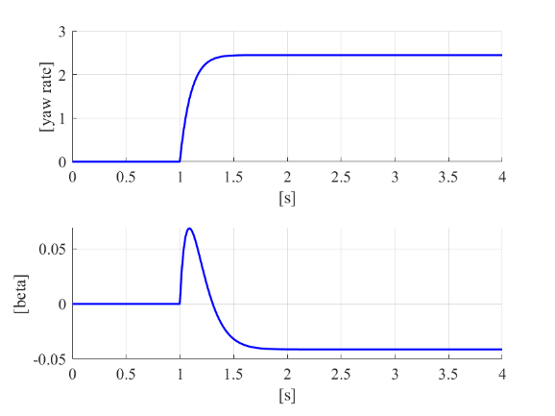

Figure 1 – Step response of the uncontrolled single-track model at 60 km/h

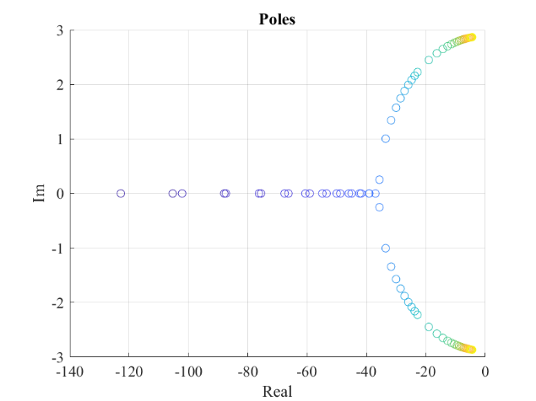

Figure 2 – Poles variation of the uncontrolled vehicle when increasing speed

In Figure 1, the yaw rate and sideslip variations show the expected behaviour to a step input: the yaw rate progressively increases until it reaches a steady-state value, while the sideslip briefly jumps to positive values when the tyre has to slip to generate lateral force and then it drops to a slightly negative value.

In Figure 2, we can observe the poles variation in function of the vehicle speed that is progressively increased from 5 up to 130 km/h. As we can see the real part decreases in magnitude when the vehicle speed is higher: the response of the vehicle becomes slower, while technically remaining stable. In addition, at about 16 km/h, the poles shift from purely real poles to complex conjugate with increased imaginary part: the system exhibits an underdamped behaviour.

### Linear state feedback lane keeping / path tracking controller

The structure of the controlled system resembles the one shown during lectures, so the control input, which is the steering angle, is given from the contribution of a feedforward term based on the curvature and a feedback term. This last contribution consists in both a proportional gain which multiplies the base state that is composed by the lateral error, heading angle error and their derivatives and an integral factor which only considers the integral of the lateral error. Furthermore, we have to point out that considering also the integral of the heading angle error leads to the uncontrollability of the entire system and was therefore not included in our extended state space formulation.

In order to tune the control gains, both pole placement and linear quadratic set-up were used. Both methods work on the extended matrices A and B of the lane keeping / path tracking problem. Independently from the tuning approach, look-up tables were built offline for different operating speeds as the controller should properly work even when the dynamics of the system change as shown in previous paragraph.

Figure 3 – Gain variation when using pole-placement (poles = [-5 -7 -10 -15 -20]

Figure 4 - Gain variation when using LQR with Q=eye(5) and R=1

### Evaluation of controller performance

The controller, with different tunings, was evaluated in three different curvature profiles: the first one is provided in the assignment along with the constant speed of 80 km/h, the second one is a skid-pad test, with fixed radius of 90 m, in which we gradually increase the speed up to 130 km/h, while the third one is an obstacle avoidance manoeuvre defined to work at 80 km/h.

Figure 5a-5b-5c - Trajectories of assigned curvature, skid-pad test and obstacle avoidance

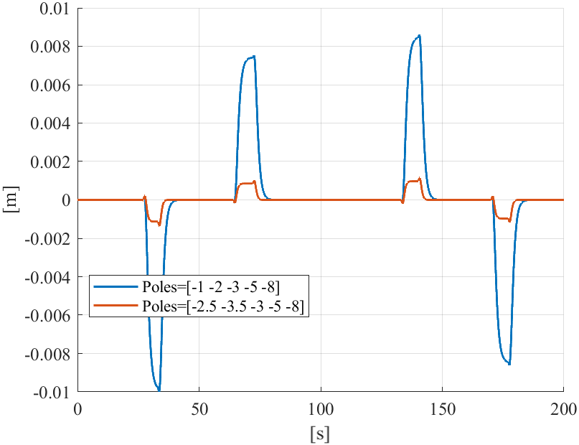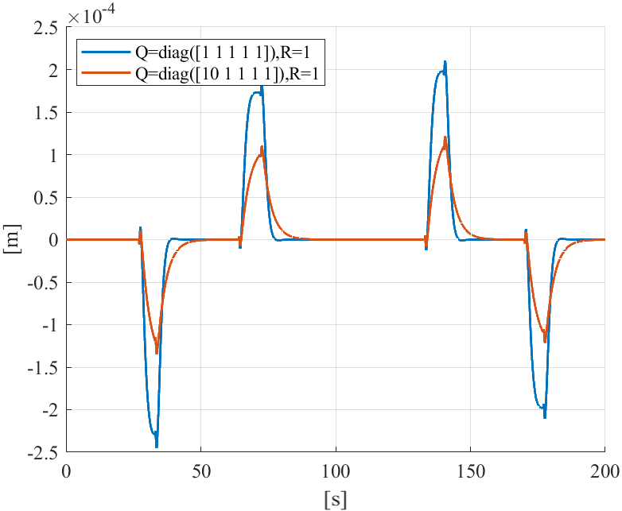

Figure 6 - Lateral deviation in the first test when using respectively different tunings with pole placement and LQR

The different tunings were all able to correctly control the vehicle in the first test, which was not too challenging. As expected, increasing in magnitude the real part of the poles, leads to lower error and a faster response, however it is also more jittery, as it can be seen in the short peaks which are more pronounced.

Two different weight matrices were chosen to evaluate the controller tunings with LQR, one with equal weights and the other one which prioritizes the lateral deviation. As expected, this last choice leads to lower error, but a slower response is obtained as a consequence. In absolute terms, the lateral error is minimal in all the considered tunings in this scenario.

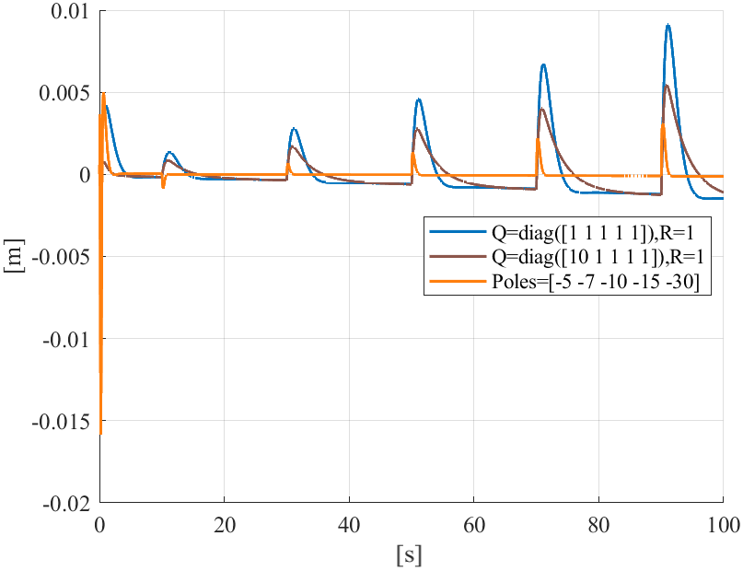

Figure 7 - Deviation error in skid-pad test

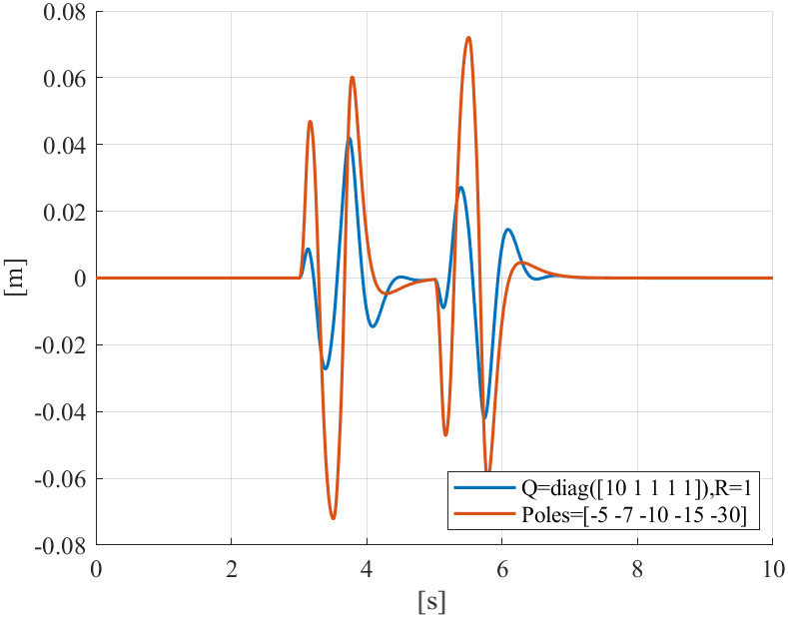

Figure 8 - Deviation error in obstacle avoidance test

In the skid-pad test (Figure 7) a constant curvature must be followed even when increasing the speed of the vehicle during the test. This scenario proved too challenging for the previous tunings with pole placement, so new poles were chosen.

In this case, the use of LQR gave us a working controller with no tuning effort, however it can be seen that the response of the controlled plant is not as fast nor as close to the ideal value of 0 because we are not directly forcing the poles.

In the third and last test, an obstacle avoidance manoeuvre is performed at a constant speed. Almost all tunings were able to follow the reference, shown in Figure 5c, showing that the more challenging scenario are related to the variation of speed and, thus, the need to change control gains if using a lookup table. For this last test we decided to also plot variables which allow us to look at the vehicle through the main variables which describe its dynamics in the single-track model (Figure 9)

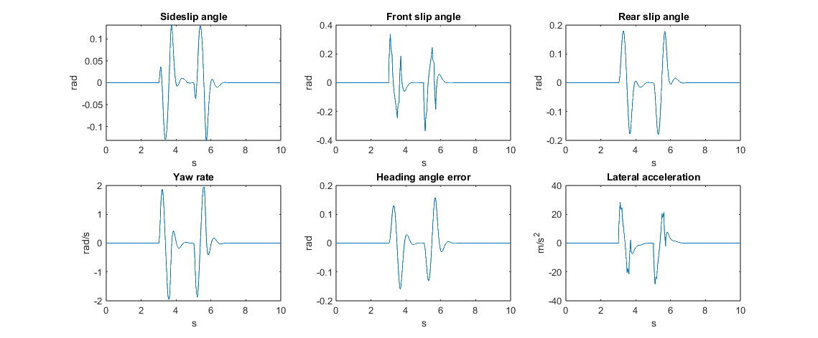

Figure 9 – Relevant single-track model variables during the obstacle avoidance test

In order to evaluate separately the contribution of the feed-forward and feed-back terms, the same trajectory of the skid-pad test was chosen but, in this case, performed at a constant speed.

The results in Figure 10 show that the feedforward term is constant, as expected for a circular trajectory at constant speed, and therefore, a fixed value of the gain, while the feedback one shows a transient in the beginning, with a slight peak, before settling to a constant value under the FF one, resulting in an overall control input that is positive in this left-turn.

Figure 10 - FF and FB terms

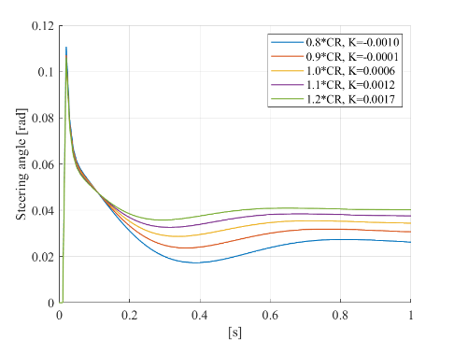

Another aspect that needs to be pointed out is how changes in the rear cornering stiffness influence the control input. Several simulations were carried out at different values under the same driving scenario considered for the evaluation of the control contributions. As a result, in Figure 11, it is evident that increasing the rear cornering stiffness leads to bigger values of the Understeer gradient which goes from a negative value, typical in oversteering vehicles, to positive values which characterize understeering vehicles. This is to be expected, as higher values indicate that the vehicle needs bigger steering angle to perform a given curve.

Figure 11 – Control input at different rear cornering stiffnesses

The last request was to consider the effect of a pure time delay which simulates the time needed for the vision system to compute the trajectory by selecting the nonzero pixel coordinates due to lines, computing a proper polynomial fitting and then using that to compute the radius and curvature at each time step. As a result, every test showed that overall control applied had no significant changes to ideal cases, and therefore was able to perform the given references. Consequently, we have chosen to leave the delay always on in our model.